Dashboard_Button Schema

Button Functions & User Interactions

Top Menu Action Buttons
- SEARCH BAR
Purpose: Global search across dealer’s ecosystem.
Workflow:
- Click → Open global search overlay
- Real-time search (debounced API)
- Show categorized results:
- Leads
- Loans
- Assets
- Inventory
- Campaigns
- Customers

- Each result clickable → redirect to respective module page
- Search parameters supported:
  - Customer Name
  - Mobile Number
  - Lead ID
  - Loan ID
  - Asset ID
  - Campaign ID
  - Inventory ID
  - Service ticket ID
- Add:
  - Recent searches
  - Fuzzy search

2. Dealer Profile Dropdown

Flow
Click → dropdown:
- View Profile
- Change Password
- Active subscription status
- Logout

Main Action Buttons

NEW LEAD

Keep Modal Flow (Click → Create New Lead Form)
- PROCESS LOAN (LOAN FACILITATION)

Logic

‘Payment_Method = Finance/Loan
AND
documents_uploaded = true
AND
facilitation_fee_status != PAID’

Probable screen:
Open Loan Facilitation Queue screen
- Table View:
Columns:
- Customer Name
- Mobile
- Document Status
- Company Validation Status
- Facilitation Fee Status
- Action
- Filters:
  - Document Uploaded
  - Under Validation
  - Validation Passed
  - Fee Pending
- Click "Process"

Open detailed pseudo screen:
- Uploaded Documents viewer
- Validation notes
- Fee amount payable
- Pay Facilitation Fee button
- On Fee Payment:
  - Update status → FEE_PAID
  - Move file to Loan Management module

- Add Assets

(Click → Pseudo Screen)
- VIEW (Recent Leads)

- Displays modal with customer information, lead status, timeline, associated loans, edit options, and action buttons
- Display time since last contact with alert if >7 days
- View Lead (Click → Lead Page)
- START CAMPAIGN
(Click → Pseudo Screen)

Probable Logic: Opens campaign wizard with audience selection, message composition, channel selection, and confirmation
- Pre-built segments: All Customers, Hot Leads, Pending Loans, Overdue Payments, Inactive Customers
- Custom segment builder with AND/OR logic
- Filter criteria: Lead status, Loan status, Purchase history, Last contact date, Location, Product interest
- Show estimated audience size as filters are applied
- Save custom segments for future use

Navigation Menu Functions
- LEAD MANAGEMENT
(Click → All Lead list with filters(Pseudo screen))
table view, sorting, bulk actions, Create New Lead button
- Loan MANAGEMENT
(Click → All Loan file list with payment processed filters, post disbursal payment and actionable(Pseudo screen))
- Deploy Asset MANAGEMENT
(Click →Deployed Asset table, filters by type payment type, product type and status, QR code generation, deployment history, maintenance tracking, battery health tracking, telemetry support (Pseudo screen))
- Service MANAGEMENT

(Click → Pseudo Screen)
- ORDERS FROM OEM

(Click → Pseudo Screen)
- INVENTORY

(Click → Pseudo Screen)

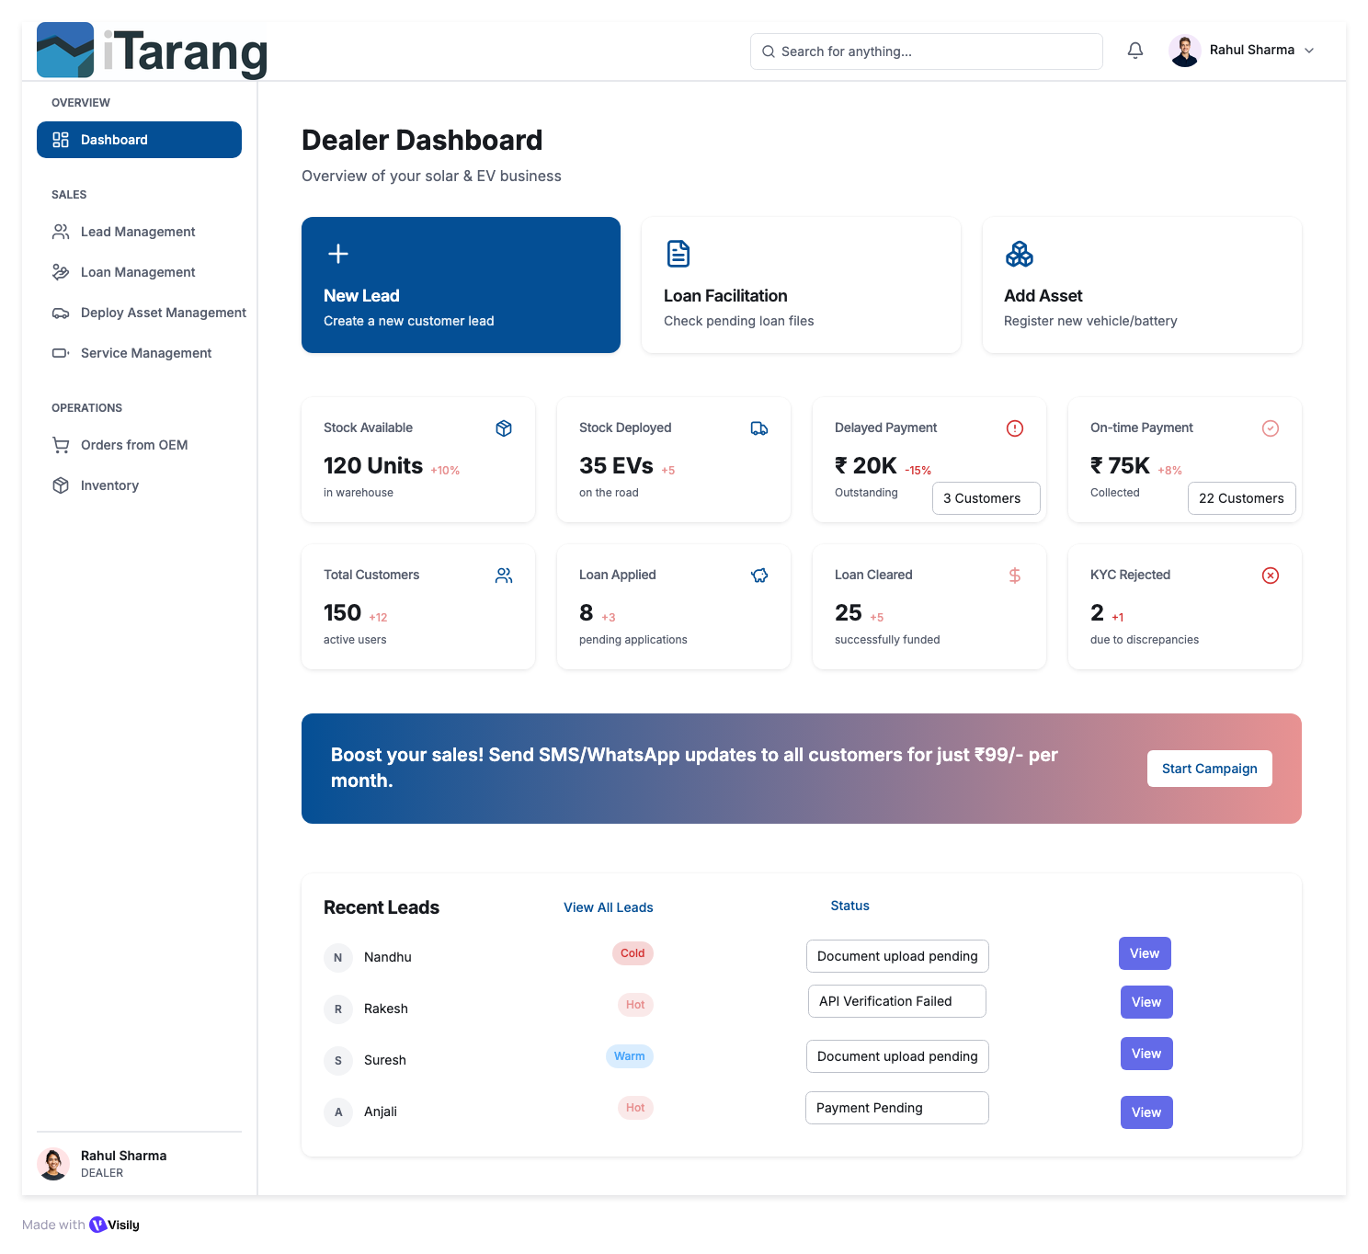

Create New Lead_Button Schema

Button Functions & User Interactions

Screen Overview
This is the first step in a 5-step workflow for creating a new lead in the iTarang CRM system. The screen collects personal information, product details, vehicle details, and lead classification data.
Workflow Position: Step 1 of 5
Reference ID Format: #IT-2026-0000001 (Auto-generated)
Generate reference: #IT-[YEAR]-[SEQUENCE]

Top Menu Action Buttons
Workflow Type: Multi-step transactional form
State: LEAD_DRAFT until final submission

- HEADER BUTTONS & ELEMENTS
Frontend:
Workflow Progress Bar
Type: Display-only component
Function
- Shows: Step 1 of 5
- Highlights current step
- Non-clickable

Backend:
- No API.
- Progress state derived from route /leads/create?step=1

- Info (ℹ️) Button
Frontend:
- On click → Open help modal
- Modal shows:
  - Required fields explanation
  - Loan compliance guidelines
  - Example formats
Backend: Static content or fetched: GET /api/help/lead-step-1
- Auto-fill from ID
Frontend
- Click → Open ‘Auto fill customer details pop up’ modal
- User click:
  - Aadhaar Front: To upload image in png, jpeg and PDF
  - Aadhaar Back: To upload image in png,jpeg and PDF
  - Start scanning: CALL API initiate OCR API, Both the uploaded images run through OCR and extract Name, Husband/Father Name, Date of Birth, Current Address
- Validation:
  - Add File Size & Format Validation
  - Max file size: 5MB per image
  - Allowed formats: PNG, JPEG, PDF
  - Image quality check (min 300 DPI recommended)
  - Show upload progress bar
  - OCR Error Handling
- What if OCR fails to extract data?:
  - Show error message: 'Could not read document. Please ensure image is clear'
  - Allow manual entry fallback
  - Retry option
  - Support for poor quality scans
Backend:
- POST /api/leads/autofillRequest: { idType: 'aadhaar|pan|customer|lead', idValue: 'string' }Response: { success: boolean, data: { fullName, fatherName, dob, address, phone, etc. }, message: string }

State Update:
- Overwrites matching fields
- Marks form as “Auto-filled”
- Logs audit event
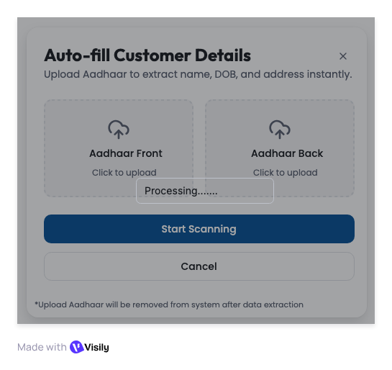

PERSONAL INFORMATION – FIELD WORKFLOW
All fields update local form state until save.

Full Name (Required)
Validation:
- 2–100 chars
- Letters + spaces + . -
- Auto-capitalize first letter of each word
- Validation: At least 2 characters
- Error message: 'Please enter a valid full name’, ‘No special characters except’
Frontend:
- Validate on blur
- Red border if invalid
Backend:
- Revalidated during submission
- Value syncs to form state

Father/Husband Name (Required for loan eligibility)
  - Same validation as Full Name.
  - If the product selected later requires a loan: → This becomes mandatory.

Date of Birth (Required)
Frontend:
- Calendar picker
- Age >= 18
- Show calculated age
Backend:
- Store ISO format

- Phone Number (Critical Field)
Frontend:
- Format: +91 XXXXX XXXXX
- Real-time validation
- AJAX duplicate check: GET /api/leads/check-duplicate?phone=9876543210
If duplicate:
- Show warning
- Provide "View Existing Lead" button
Backend:
- Store with +91
- Soft duplicate allowed (with warning log)

Current Address (Optional)
- Min 20 characters

- Permanent Address (Optional)
  - Min 20 characters
  - ☑ Same as Current: if checked ‘Auto copy’
Backend:
- Store boolean is_current_same

PRODUCT DETAILS – CONDITIONAL LOGIC
- Product Category (Required)
Fetch: GET /api/inventory/categories
Selection triggers:
- Load Product Types
- Determine if vehicle section visible

- Product Type (Required)
Fetch: GET /api/inventory/products?category=3-Wheeler
Must store:
- Product_Type ids
- Multiselect as per Product category
- Add 'Add Another Product' button to create multiple entries
- Consider: Primary product (required) + Secondary products (optional)
- If not in stock → show: “Order from OEM” suggestion

- VEHICLE DETAILS (Conditional Block)
  - Visible only if:Product category = 3W/2W/4W

- Vehicle Registration Number (Mandatory)
  - Auto uppercase’

- Vehicle Ownership
  - vehicle_registration_number IS NOT NULL
  - if the user fills Vehicle Reg. Number
    - Show validation: 'You've entered vehicle details
    - Automatically make dependent fields required: •
      - Vehicle Ownership (Required)
      - Owner Name (Required)
      - Owner Phone (Required)
    - Show asterisk (*) dynamically on these fields.
    - Add section heading: 'Existing Vehicle Information' (for context)
Dropdown:
- Self
- Financed
- Company
- Leased
- Family
Conditional fields appear based on selection.

- Owner Name
  - Name format same as ‘Full Name’.
  - vehicle_registration_number IS NOT NULL
  - if user fills Vehicle Reg. Number:
    - Show validation: 'You've entered vehicle details'
    - Automatically make dependent fields required:
      - Vehicle Ownership (Required)
      - Owner Name (Required)
      - Owner Phone (Required)
    - Show asterisk (*) dynamically on these fields
    - Add section heading: 'Existing Vehicle Information' (for context)
- Owner Phone
  - The phone format is the same as ‘Phone Number’.
  - vehicle_registration_number IS NOT NULL
  - if the user fills Vehicle Reg. Number:
  - Show validation:
    - 'You've entered vehicle details'
    - Automatically make dependent fields required:
      - Vehicle Ownership (Required)
      - Owner Name (Required)
      - Owner Phone (Required)
  - Show asterisk (*) dynamically on these fields
  - Add section heading: 'Existing Vehicle Information' (for context)
LEAD CLASSIFICATION
- Hot / Warm / Cold (Required)
Frontend:
- Toggle group
- Must select one
Backend:
Stores:
- interest_level: hot | warm | cold
- lead_score: computed_value
Suggested scoring:
- Hot → 90
- Warm → 60
- Cold → 30
Triggers:
- Hot leads: 'Create Lead' saves Step 1 and auto-navigates to Step 2
- Warm/Cold: 'Create Lead' saves and exits workflow
BOTTOM BUTTONS – CORE LOGIC
- Create Lead
Purpose: Immediate save & exit workflow

Frontend:
- Validate all required fields
- If errors → highlight
- If valid → confirm modal:Create lead
- On confirm:
  - Disable button
  - Show spinner
  - Call API
Backend:
- POST /api/leads/create
Actions:
- Server-side validation
- Generate reference:
#IT-[YEAR]-[SEQUENCE]
- Set:
status = INCOMPLETE
workflow_step = 1
- Save to leads table
- Create activity log
- Trigger notifications if HOT
Response
{success: true,
leadId,
referenceId}
- After Success
- Toast: Lead created
- Redirect to:
/leads/:id

- Cancel

Frontend:

If form untouched: → Go back

If modified:→ Show confirmation modal

On confirm:
- Clear local state
- Delete draft if exists:
  - DELETE /api/leads/draft/:sessionId
  - Redirect to dashboard
STATE MANAGEMENT LOGIC
During Step 1:
- form_state = LOCAL
- lead_state = DRAFT (optional)
After Create Lead:
- lead_status = INCOMPLETE
- workflow_step = 1

Button | Frontend Action | Backend Action | State Change
info | Open modal | None | None
Auto-fill | Call autofill API | Return data | Populate form
Create Lead | Validate → POST | Insert Lead | incomplete
Cancel | Confirm → Navigate | Delete draft (optional) | Discard

Error Handling
For every API call and user action, specify:
  - Network errors: 'Connection lost. Please try again'
  - Validation errors: Field-specific error messages
  - Server errors (500): 'Something went wrong. Contact support'
  - Permission errors (403): 'You don't have permission'
  - Timeout errors: Retry mechanism with exponential backoff

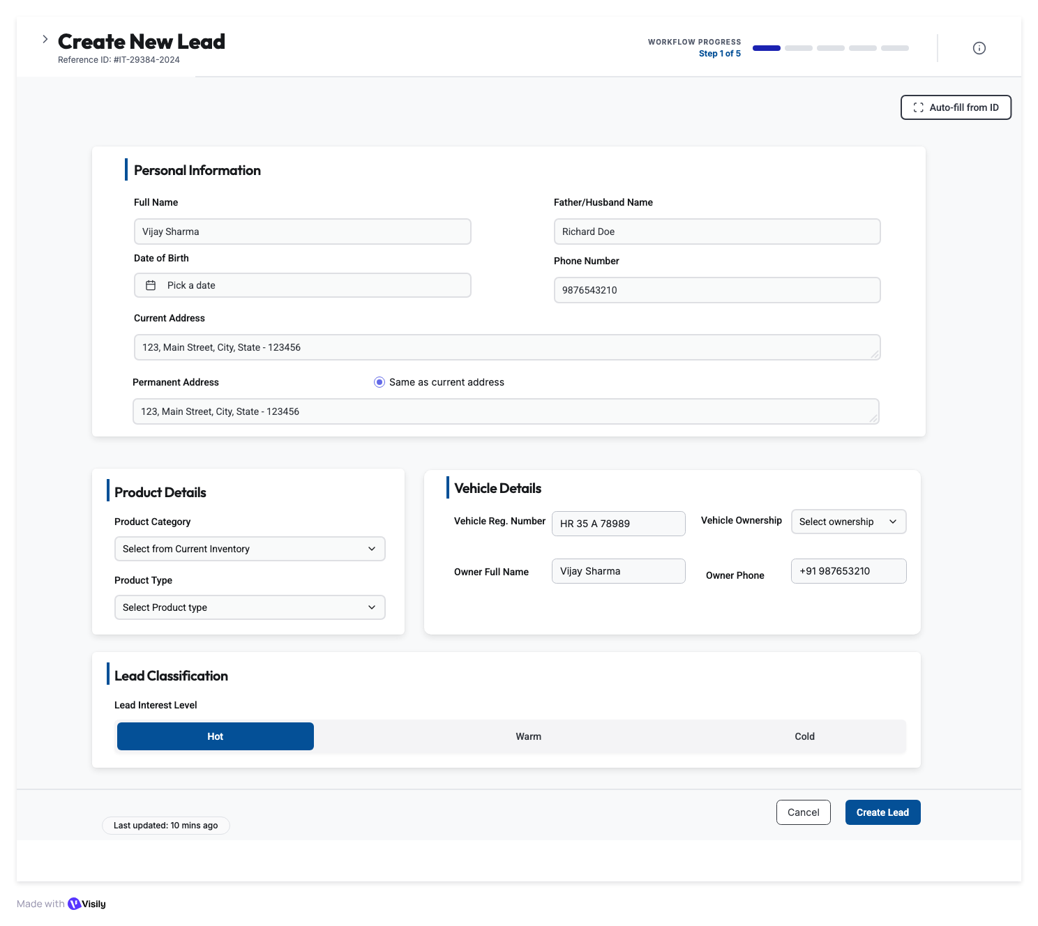

Customer KYC – Step 2 of 5 (Hot Lead Only)_Button Schema
SCREEN ACCESS LOGIC
Access Condition
- User can access Step 2 only if:

lead_created = true
AND interest_level = 'hot'

Backend Gatekeeper
- GET /api/kyc/:leadId/access-check
- If not allowed → redirect to the ‘Create Lead Page’

PAYMENT METHOD
- Payment Method Dropdown (Required)
Options:
- Upfront Full Payment
- Finance / Loan (default)
Frontend Logic
On change:
- If upfront Full Payment:
  - Hide Loan Documents
  - Hide Bank Statements
  - Hide Cheques
  - Required Docs = Basic KYC only
- If finance/Loan:
  - Show full Loan Documents section
- Required Docs = 11
Backend:
- PATCH /api/kyc/:leadId/payment-method
Store:
- payment_method = 'upfront' | 'finance'
- loan_required = true/false
Return:
- requiredDocuments[]

- DOCUMENT UPLOAD CARDS
- (Only visible if payment_method = finance)
- Uploader

Common Upload Flow (All Document Cards)

Frontend:
- Click card
- Open file picker
- Validate type & size
- Show progress
- On success:
  - Green check
  - Thumbnail preview
  - Update count
Backend:
- POST /api/kyc/:leadId/upload-document
Payload:
- documentType: file
Store:
- File URL
- Uploaded timestamp
- Initial status = 'pending'
DOCUMENT-SPECIFIC LOGIC

Aadhaar Front & Back
- Required
- OCR extraction
- Cross-match name & DOB using API as per ‘https://decentro.tech/resources/identity-verification
- Cross-match address (Back) using API as per ‘https://decentro.tech/resources/identity-verification
- Cross-match Father/Husband Name using API as per ‘https://decentro.tech/resources/identity-verification
- Authenticate aadhar using API as per ‘https://decentro.tech/resources/identity-verification
- aadhaar_verification_status:
  - pending → in_progress → success | failed
  - Fail Reason to be specified as per ‘https://decentro.tech/resources/identity-verification
PAN Card
- Required
- Validate format
- Cross-check name with Aadhaar and using API as per ‘https://decentro.tech/resources/identity-verification PAN
- Cross-check DOB with Aadhaar and using API as per ‘https://decentro.tech/resources/identity-verification PAN
- Cross-check Father/Husband name with Aadhaar and using API as per ‘https://decentro.tech/resources/identity-verification PAN
- Authenticate PAN using API as per ‘https://decentro.tech/resources/identity-verification
- PAN_verification_status:
  - pending → in_progress → success | failed
  - Fail Reason to be specified as per ‘https://decentro.tech/resources/identity-verification
Passport Photo
- Required
- Face detection
- Min resolution check
- Cross-check photo with Adhaar using API as per ‘https://decentro.tech/resources/identity-verification
- If mismatch > 20% → Status = failed
- Photo Verification status:
  - pending → in_progress → success | failed
  - Fail Reason to be specified as per ‘https://decentro.tech/resources/identity-verification
Address Proof
- Required
- Fuzzy match with Current address
- <80% match → Status = failed
- Address Verification status:
  - pending → in_progress → success | failed
  - Fail Reason → Address mismatch with updated permanent address
RC Copy (Conditional)
- Required only if: Asset Category = 3W/2W/4W and != Inverter
- Verify authentication via VAHAN API using https://surepass.io/vahan-verification-api/
- Cross-check reg number and Owner Name mentioned before
- Authenticate RC using API as per https://surepass.io/vahan-verification-api/
- RC_verification_status:
  - pending → in_progress → success | failed
  - Fail Reason to be specified as per https://surepass.io/vahan-verification-api/
Bank Statement
- Required
- OCR to Read Beneficiary name, Account number, Bank, Branch, IFSC
- All details to be stored in a table
- Cross-check Beneficiary name with Customer Name
- Use Penny drop verification to authenticate account https://decentro.tech/resources/penny-drop-verification-api
- Bank Statement_verification_status:
  - pending → in_progress → success | failed
  - Fail Reason to be specified as per Beneficiary name mismatch and https://decentro.tech/resources/penny-drop-verification-api
Undated Cheques (4 Required)
Frontend:
- 4 slots mandatory
- Show progress: 3/4
Backend:
- OCR account number
- Ensure same account across cheques (Fail1)
- Ensure account matches with uploaded Bank document (Fail2)
- Bank Statement_verification_status:
  - pending → in_progress → success | failed
  - Fail Reason to be specified for
    - Fail1: Different cheques uploaded, please upload cheques for same account
    - Bank statement and cheques are not matching
DOCUMENT STATUS COUNTER
Status Display:
- Documents Uploaded: 09/11 - Shows count of completed uploads
- Documents Pending: PAN Card, Passport Size Photo - Lists missing docs in red text
- Auto-updates as user uploads documents
Backend Calculation:
GET /api/kyc/:leadId/document-statusResponse: { totalRequired: 11, uploaded: 9, pending: ['pan_card', 'passport_photo'], allComplete: false}

- CUSTOMER CONSENT

Send SMS/WhatsApp Consent
Frontend:
- Click button:Send SMS/WhatsApp Consent
- Disable ‘Generate Consent PDF’ and ‘upload signed consent PDF’
- Validate: Customer phone number exists
- Prepare Consent Form with prefilled details
- Prepare consent form link to be sent on a registered mobile number
- Show confirmation modal: 'Send consent form link to +91-XXXXX-XXXXX?
- Show option to choose WhatsApp or SMS
- Cancel button on all screen
- On confirm:
  - Disable button
  - Show spinner
  - Call API
- On success:
  - Show toast: 'Consent form sent to customer'
  - Update Consent Status: 'Link Sent - Awaiting Response'

Backend:
- POST /api/kyc/:leadId/send-consent
- Validate: leadId exists, phone number valid
- Generate consent document:
  - Header: Company logo, Consent form title
  - Body: Pre-filled customer details, loan terms, consent text
  - Footer: Signature fields (Customer, Aadhar OTP Verication ID, Date)
- Generate unique consent link: https://tarang.com/consent/{leadId}/{token}
- Send SMS via Twilio or other preferred method: 'Complete your loan consent: {link}. Valid for 24 hours. -iTarang
- Send WhatsApp message (if opted in)
- Store in database: consent_link_sent_at = CURRENT_TIMESTAMP consent_token = generated_token consent_status = 'link_sent'
- 7. Return: { success: true, sentAt: timestamp }
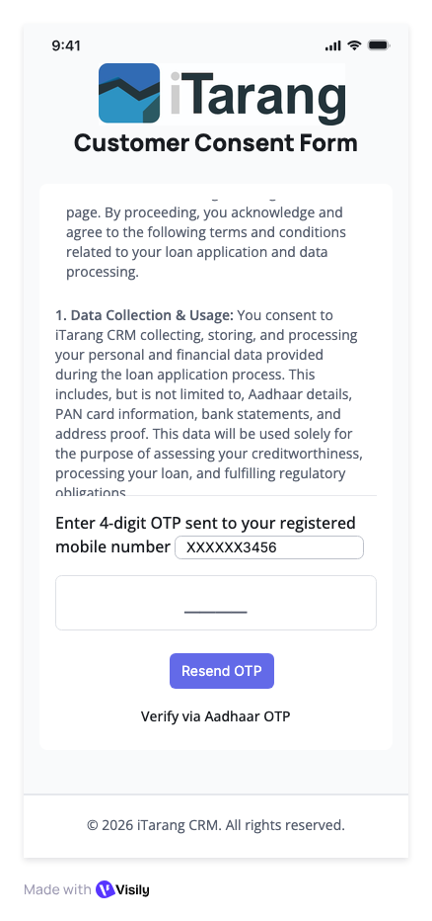

Generate Consent PDF
Frontend:
- Click button: Generate Consent PDF
- Disable ‘Send SMS/WhatsApp Consent’
- Show loading spinner
- Call API
- On success:
  - Download PDF automatically
  - Show toast: 'Consent PDF downloaded'
  - Enable 'Upload signed consent PDF' button
- Keep Cancel button to restart
Backend:
- POST /api/kyc/:leadId/generate-consent-pdf
- Fetch lead data: Name, Father name, Address, Product details
- Generate PDF using template:
  - Header: Company logo, Consent form title
  - Body: Pre-filled customer details, loan terms, consent text
  - Footer: Signature fields (Customer, Witness, Date)
- Store PDF temporarily: /temp/consent_{leadId}.pdf
- Return: { success: true, pdfUrl: string, expiresIn: 3600 }PDF Template:
  - Library: pdfkit or puppeteer
  - Include: Consent text for credit check, loan agreement, data sharing
  - Signature boxes: Customer signature, Date, Witness signature, Customer Thumb Print

Upload Signed Consent PDF Button
Frontend:
- Enabled only after 'Generate Consent PDF' is clicked
- Click → Open file picker
- Accepted: PDF only
- Max size: 10MB
- Show upload progress.
- On success:
  - Update Consent Status: 'Manual Consent Uploaded'
  - Show preview thumbnail
  - Mark as asterisk (*) required field fulfilled
Backend:
- POST /api/kyc/:leadId/upload-signed-consent
- Payload: FormData { file: File }
- Validate: PDF format, size <10MB
- Upload to S3: /kyc/{leadId}/signed_consent.pdf
- Store URL: signed_consent_url
- Update: consent_status = 'manual_uploaded'
- Create verification task for admin: 'Review manual consent'
- Return: { success: true, fileUrl: string }

Consent Status Display
Status Values:
- 'Awaiting digital Signature' - Default state, no action taken
- 'Link Sent - Awaiting Response' - SMS/WhatsApp sent, waiting for customer
- 'Digitally Signed' - Customer completed e-signature
- 'Manual Consent Uploaded' - Offline signed PDF uploaded
- 'Verified' - Admin approved the consent

- VERIFICATION ACTION

Coupon Code Field
Frontend:
- Text input field
- Placeholder: 'Enter verification coupon code'
- Max length: 20 characters
- Alphanumeric only
- Required

Backend:
- Validates coupon code against dealer specific assigned coupon codes API
- If valid: strike off and enable verification
- If invalid: Show error 'Invalid coupon code'
- Store: coupon_code, coupon_applied_at, coupon_status change to used

Validate Button
Frontend:
- Check if coupon code entered
- If empty: Show error 'Please enter coupon code’
- If filled:
  - Disable button
  - show spinner
  - Call validation API
- On success:
  - Show toast: 'Coupon validated
  - Enable 'Submit for Verification' button
- On failure:
  - Show error: 'Invalid coupon or expired'
  - Keep 'Submit for Verification' disabled
Backend:
- POST /api/kyc/validate-coupon
- Payload: { couponCode: string }
- Call API: Verify coupon
- If valid: Store coupon_available
  - Mark coupon as validated
- Return: { valid: boolean, creditsAvailable: number, message: string }

Submit for Verification Button
Trigger automated verification of Aadhaar, PAN, Bank via third-party APIs, Trigger Fetch API for CIBIL via Third Party Verification API

At the validation screen iTarang team can ask for other documents and those document requirements will be reflected in the Other Documents & Co-Borrower KYC Screen (Interim Step).

Frontend:
- Pre-check:
  - All required documents uploaded? (11/11)
- If not complete:
  - Show error: 'Please upload all required documents'
    - Highlight missing documents in red
- If complete:
  - Show confirmation modal:'Submit documents for verification?
- On confirm:
  - Disable button, show spinner
  - Call verification API
- On success:
  - Show toast: 'Verification initiated. Check the status below.'
  - Scroll to 'Verification Status' table
  - Auto-refresh status every 30 seconds
  - Send all the attachments and customer details for manual validation by iTarang internal team (Internal validation Dashboard connected to lead ID)
- On failure:
  - Show error message
    - Re-upload button

Backend:
- POST /api/kyc/:leadId/submit-verification
- Validate:
  - All required docs uploaded
  - Extract data from uploaded documents (OCR)
  - Call third-party APIs sequentially:
    - Aadhaar Verification:
      - API: DigiLocker or UIDAI API
      - Verify: Aadhaar number, Name, DOB, Address, Father/Husband Name
      - Update: aadhaar_verification_status = 'in_progress'
    - PAN Verification:
      - API: PAN Verification
      - Verify: PAN number, Name
      - Cross-check name with Aadhaar
      - Update: pan_verification_status = 'in_progress'
    - Bank Verification:
      - API: Penny drop or Bank statement parser
      - Verify: Account number, IFSC, Name
      - Update: bank_verification_status = 'in_progress'
    - Address Verification:
      - Compare: Aadhaar address vs Address proof
      - Fuzzy match score
      - Update: address_verification_status = 'in_progress'
    - RC Verification (if applicable):
      - API: VAHAN API
      - Verify: Registration number, Owner name
      - Update: rc_verification_status = 'in_progress'
    - Mobile Number Verification:
      - Send OTP to customer phone
      - Update: mobile_verification_status = 'awaiting_action'
  - Store verification_submitted_at = CURRENT_TIMESTAMP
  - Create webhook listeners for async API responses.
  - Return: { success: true, verificationsInitiated: 6, estimatedTime: '2-5 minutes' }
  - Disable upload/edit for that section until the admin responds.

Verification Status (Co-borrower) Table
Real-time display of document verification status from third-party APIs

Table Structure
Columns:
- Check - Verification type (Aadhaar, PAN, Bank, etc.)
- Status - Current verification state (badge/pill)
- Last Update - Timestamp of last status change
- Action - Re-upload button for failed verifications
- Failed Reason - Error message if verification failed

Status Values & Visual Indicators
• System initiating data fetch: Orange badge - Verification API called, waiting for response
• Awaiting action: Gray badge - Waiting for user action (e.g., OTP entry)
• Success: Green badge - Verification passed successfully
• Failed: Red badge - Verification failed - see reason
• Pending: Yellow badge - Verification in queue or processing

Individual Verification Rows
Aadhaar Verification
- Status: System initiating data fetch
- Last Update: 2024-07-26 10:30 AM
- Action: Re-upload
- Failed Reason:
Technical Details:
Frontend:
- Auto-updates via WebSocket or polling (every 10 sec)
- Shows spinner during 'initiating' state
Backend:
- Calls DigiLocker/UIDAI API/Decentro API
- Validates: Aadhaar number format, Name match, DOB match
- Updates status based on API response
- Possible outcomes: Success, Failed (name mismatch), Failed (invalid Aadhaar)
PAN Verification
- Status: Awaiting action
- Last Update: 2024-07-26 10:45 AM
- Action: Re-upload
- Failed Reason:
Technical Details:
Frontend:
- Gray badge indicates waiting state
- May require OTP or additional step
Backend:
- Calls Income Tax API or NSDL/Decentro API
- Validates: PAN format, Name match with Aadhaar
- If name mismatch:
  - Set status = Failed, reason = 'Name mismatch'
- If inactive PAN:
  - Set status = Failed, reason = 'PAN inactive or invalid'
Bank Verification
- Status: Awaiting action
- Last Update: 2024-07-26 10:45 AM
- Action: Re-upload
- Failed Reason:
Technical Details:
Frontend:
- May show 'Verify with Penny Drop' button
- Customer enters: Account number, IFSC code
Backend:
- Penny drop test: Deposit ₹1, verify account active
- parse bank statement for account details
- Validates: Account holder name matches customer name
- Checks: Account active, not frozen
Address Proof
- Status: Failed
- Last Update: 2024-07-26 10:45 AM
- Action: Re-upload
- Failed Reason: Address is not match
Technical Details:
Frontend:
- Red badge, Failed reason shown•
- ‘Re-upload' button enabled
- On click: Opens file picker to upload new address proofBackend:
  - Fuzzy match: Aadhaar address vs Address proof address•
  - If similarity <70%: Mark as Failed
  - Reason: 'Address mismatch. Please upload correct proof.'
  - Re-upload triggers new verification cycle
RC Verification
- Status: Failed
- Last Update: 2024-07-26 10:45 AM
- Action: Re-upload
- Failed Reason: Image Blur
Technical Details:
Frontend:
- Failed due to poor image quality
- 'Re-upload' button enabledBackend:
  - OCR quality check: Image clarity score
  - If score <60%: Mark as Failed, reason = 'Image blur or low quality'
- Calls VAHAN API to verify RC number
- Cross-checks: Owner name, Vehicle model
Mobile Number
- Status: Success
- Last Update: 2024-07-26 10:45 AM
- Action: Re-upload
- Failed Reason:
Technical Details:
Frontend:
- Green badge, verification complete
- OTP sent and verifiedBackend:
  - Sends OTP to customer's mobile
  - Customer enters OTP in modal/popup
  - Validates OTP within 5 minutes
  - On success: Mark as Success
  - On failure: Failed Reason

Re-upload Button Functionality
Frontend Workflow:
- Enabled only for 'Failed' status rows
- Click → Open file picker (specific to document type)
- Upload new document
- On success:
  - Reset status to 'Awaiting action'
  - Clear 'Failed Reason'
  - Show toast: 'Document re-uploaded
  - Verification will restart.'
- Auto-trigger verification for that specific document
Backend:
- POST /api/kyc/:leadId/re-upload
- Payload: { verificationType: 'aadhaar|pan|bank|etc', file: File }
- Delete old file from storage
- Upload new file
- Update: document_url, verification_status = 'awaiting_action'
- Re-trigger specific verification API
- Update: last_update = CURRENT_TIMESTAMP
- Return: { success: true, newStatus: 'awaiting_action' }

Consent Status Display (Top Right)
Current Display: 'Consent Status: Success' (Green badge)
This indicates the customer has completed consent (digital or manual).
Backend Logic:
- If consent_status = 'digitally_signed' OR 'manual_uploaded': Show 'Success'
  - If consent_status = 'link_sent': Show 'Pending'
  - If consent_status = 'awaiting_signature': Show 'Not Started'

Admin Review Outcomes
When iTarang reviews the documents, they have three simple outcomes per document:
- Verified
- Rejected – Need better clarity
- Request additional document (adds new doc type to list)
Frontend converts these into UI:
- Verified → Green tick
- Rejected → Red label with reason
- New doc request → New tile appears

- Bottom Action Buttons
Back Button

Frontend:
- Check if any data is modified on current page
- If modified:
  - Show confirmation: 'You have unsaved changes. Go back?'
  - Options: 'Save Draft & Go Back' / 'Discard & Go Back' / 'Cancel'
- If 'Save Draft':
  - Call save draft API
  - Save the draft
- If 'Discard':
  - Clear form state.
  - Navigate to last saved form/draft
    - If draft save: PATCH /api/kyc/:leadId/draft { step: 2, data: {...} }

Save Draft Button
Frontend Workflow:
- Collect all form data:
  - Payment method
  - Uploaded documents (URLs)
  - Verification statuses
  - Consent status
  - Other documents
- Show loading spinner on button
- Call save draft API
- On success:
  - Show toast: 'Draft saved successfully'
  - Update 'Last updated' timestamp
  - Keep user on the same page
- On failure:
  - Show error: 'Failed to save draft. Please try again.
Backend:
- PATCH /api/kyc/:leadId/save-draft
- Payload: { step: 2, data: { paymentMethod, documents: {...}, verificationStatus: {...}, consent: {...} } }
- Update database: kyc_draft_data = JSON payload draft_saved_at = CURRENT_TIMESTAMP workflow_step = 2 kyc_status = 'draft'
- Return: { success: true, savedAt: timestamp }Auto-save:
  - Trigger auto-save every 2 minutes if user idle
  - Show subtle indicator: 'Auto-saved at HH:MM'

Save & Next Button (Conditional)
Condition: iTarant internal team has validated the document, all APIs has shown success or iTarang team has requested for other documents or iTarang team has requested for Co-Borrower details

Frontend Workflow:
- Validation checks:
  - ✓ Payment method selected
  - ✓ All required documents uploaded (11/11 if Finance, 3/11 if Upfront)
  - ✓ Consent obtained (Status = Success)
  - ✓ No critical verification failures
  - ✓ Internal validation success or Internal validation requested for other documentation and/or co-borrower information
- If validation fails:
  - Show error modal with checklist:
  - ❌ Missing: PAN Card upload ❌ Aadhaar verification failed ✓ Consent obtained
  - Highlight incomplete sections in red
  - Scroll to first error
  - Keep on same page
- If validation passes and no other documents and/or co-borrower information required:
  - Show confirmation: 'KYC data is complete. Proceed to Product Selection?'
    - On confirm:
      - Disable button, show spinner
      - Call save API
      - On success: Navigate to Step 3
      - On failure: Show error, re-enable button
- If validation passes and other documents and/or co-borrower information required:
  - Show confirmation: 'Other Documentation is required. Proceed to Next Page Selection?'
    - On confirm:
      - Disable button, show spinner
      - Call save API
      - On success: Navigate to Interim Step
      - On failure: Show error, re-enable button
Backend:
- POST /api/kyc/:leadId/complete-and-next
- Server-side validation:
  - Check: All required documents uploaded
  - Check: Consent status = 'digitally_signed' OR 'manual_uploaded'
- If validation fails:
  - Return: { success: false, errors: [...], missingItems: [...] }
- If validation passes:
  - Update lead status: kyc_status = 'completed' kyc_completed_at = CURRENT_TIMESTAMP workflow_step = 3
  - Calculate KYC score: kyc_score = ( (documents_uploaded / total_required) * 40 + (verifications_passed / total_verifications) * 40 + (consent_obtained ? 20 : 0) )
  - Store final KYC data: kyc_data = JSON { paymentMethod, documents, verifications, consent }
  - Create activity log: 'KYC completed for Lead #{leadId}'
  - Trigger notifications:
    - Email to dealer: 'KYC approved for {customer_name}'
    - SMS to customer: 'Your KYC is verified. Next: Select product.'
  - Return: { success: true, nextStep: 3, kycScore: 95, message: 'KYC completed successfully' }
- Frontend receives success:
  - Show success toast: 'KYC completed! Proceeding to product selection...'
  - Navigate to: /leads/:leadId/product-selection (Step 3)
  - Update progress bar: Step 3 of 5

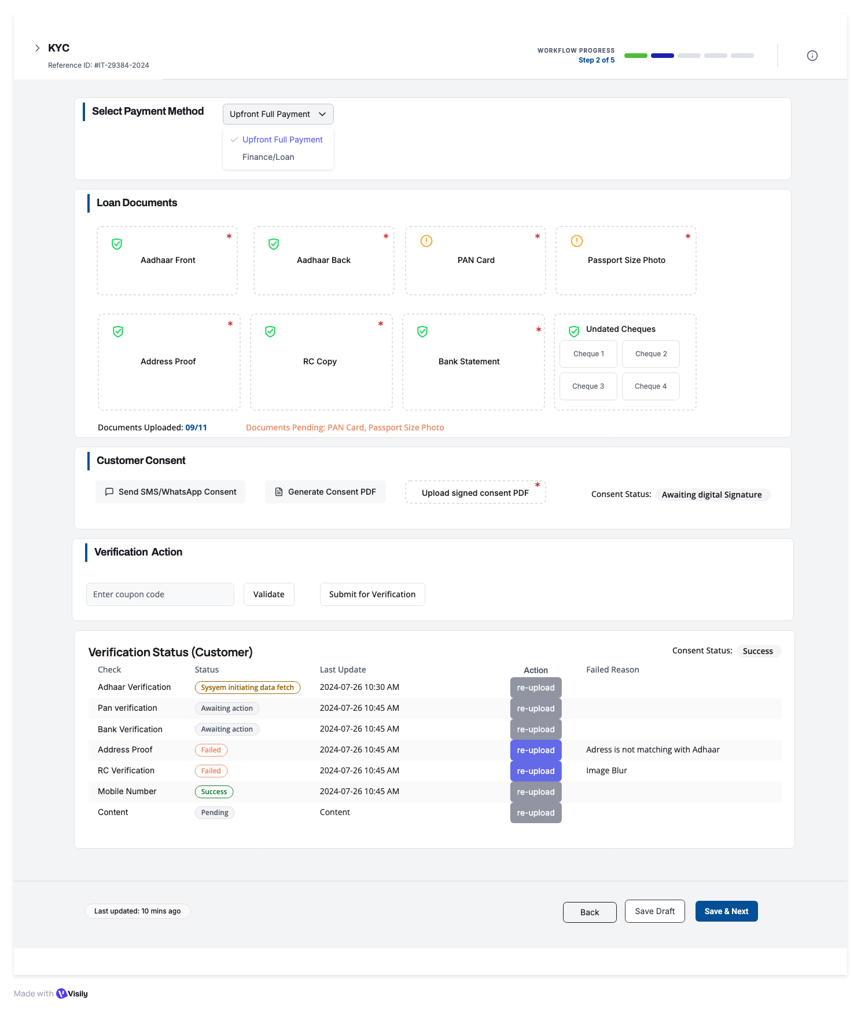

Other Documents & Co-Borrower KYC – Interim Step (Only If required by internal validation)_Button Schema

ACCESS LOGIC
This screen appears only if:
lead.has_additional_docs_required = true
OR
lead.has_co_borrower = true
Backend gatekeeper:
GET /api/kyc/:leadId/interim-access-check
If false → redirect to Step 3 accordingly.

- CO-BORROWER / GUARANTOR INFORMATION
Visible only when:
lead.has_co_borrower = true

Fields (8 total)
- Full Name
- Father/Husband Name
- Date of Birth
- Phone
- Permanent Address
- Current Address (+ checkbox “Same as permanent”)
- PAN
- Aadhaar
Validation
- Same as primary applicant KYC
- Age ≥ 18
- Co-borrower phone ≠ applicant phone
Auto-Fill from ID
Frontend
- Click → Open ‘Auto fill customer details pop up’ modal
- User click:
  - Aadhaar Front: To upload image in png, jpeg and PDF
  - Aadhaar Back: To upload image in png,jpeg and PDF
  - Start scanning: CALL API initiate OCR API, Both the uploaded images run through OCR and extract Name, Husband/Father Name, Date of Birth, Current Address
- Validation:
  - Add File Size & Format Validation
  - Max file size: 5MB per image
  - Allowed formats: PNG, JPEG, PDF
  - Image quality check (min 300 DPI recommended)
  - Show upload progress bar
  - OCR Error Handling
- What if OCR fails to extract data?
  - Show error message: 'Could not read document. Please ensure image is clear'
  - Allow manual entry fallback
  - Retry option
  - Support for poor quality scans
Backend
POST /api/leads/autofillRequest: { idType: 'aadhaar|pan|customer|lead', idValue: 'string' }Response: { success: boolean, data: { fullName, fatherName, dob, address, phone, etc. }, message: string }

State Update

Overwrites matching fields

Marks form as “Auto-filled”

Logs audit event

CO-BORROWER DOCUMENT UPLOAD (4 Required)

Document tiles (same as customer KYC):
- Aadhaar Front
  - Required
- Aadhaar Back
  - Required
- PAN Card
  - Required
- Passport Photo
  - Required
- Address Proof
  - Optional
- Bank Statement
  - Optional
  - 7–10. 4× Undated Cheques
- RC Copy (only if vehicle category is 2W/3W/4W)
  - Optional
Upload Flow
Frontend:
- Click tile → choose file
- Validate size/type
- Show upload progress
- Show green tick on success
Backend: POST /api/coborrower/:leadId/upload-document
Stores: url, doc_type, uploaded_at, status="pending"
Document Status Counter
API: GET /api/coborrower/:leadId/document-status
Displays:
- “Documents Uploaded: X/11”
- Pending list (e.g., PAN, Passport)
Progress bar → Success: Change to green checkmarkPENDING ALERT:Shows: 'Documents Pending: PAN Card, Passport Size Photo' in red/orange text
- CO-BORROWER CONSENT
Send SMS/WhatsApp Consent
Frontend:
- Click button:Send SMS/WhatsApp Consent
- Disable ‘Generate Consent PDF’ and ‘upload signed consent PDF’
- Validate: Customer phone number exists
- Prepare Consent Form with prefilled details
- Prepare consent form link to be sent on a registered mobile number
- Show confirmation modal: 'Send consent form link to +91-XXXXX-XXXXX?
- Show option to choose WhatsApp or SMS
- Cancel button on all screen
- On confirm:
  - Disable button
  - Show spinner
  - Call API
- On success:
  - Show toast: 'Consent form sent to customer'
  - Update Consent Status: 'Link Sent - Awaiting Response'

Backend:
- POST /api/coborrower/:leadId/send-consent
- Validate: leadId exists, phone number valid
- Generate consent document:
  - Header: Company logo, Consent form title
  - Body: Pre-filled customer details, loan terms, consent text
  - Footer: Signature fields (Customer, Aadhar OTP Verication ID, Date)
- Generate unique consent link: https://tarang.com/coborrowerconsent/{leadId}/{token}
- Send SMS via Twilio or other preferred method: 'Complete your loan consent: {link}. Valid for 24 hours. -iTarang
- Send WhatsApp message (if opted in)
- Store in database: consent_link_sent_at = CURRENT_TIMESTAMP consent_token = generated_token consent_status = 'link_sent'
- 7. Return: { success: true, sentAt: timestamp }

Generate Consent PDF
Frontend:
- Click button: Generate Consent PDF
- Disable ‘Send SMS/WhatsApp Consent’
- Show loading spinner
- Call API
- On success:
  - Download PDF automatically
  - Show toast: 'Consent PDF downloaded'
  - Enable 'Upload signed consent PDF' button
- Keep Cancel button to restart
Backend:
- POST /api/coborrower/:leadId/generate-consent-pdf
- Fetch lead data: Name, Father name, Address, Product details
- Generate PDF using template:
  - Header: Company logo, Consent form title
  - Body: Pre-filled customer details, loan terms, consent text
  - Footer: Signature fields (Customer, Witness, Date)
- Store PDF temporarily: /temp/consent_{leadId}.pdf
- Return: { success: true, pdfUrl: string, expiresIn: 3600 }PDF Template:
  - Library: pdfkit or puppeteer
  - Include: Consent text for credit check, loan agreement, data sharing
  - Signature boxes: Customer signature, Date, Witness signature, Customer Thumb Print

Upload Signed Consent PDF Button
Frontend:
- Enabled only after 'Generate Consent PDF' is clicked
- Click → Open file picker
- Accepted: PDF only
- Max size: 10MB
- Show upload progress.
- On success:
  - Update Consent Status: 'Manual Consent Uploaded'
  - Show preview thumbnail
  - Mark as asterisk (*) required field fulfilled
Backend:
- POST /api/coborrower/:leadId/upload-signed-consent
- Payload: FormData { file: File }
- Validate: PDF format, size <10MB
- Upload to S3: /kyc/{leadId}/signed_consent.pdf
- Store URL: signed_consent_url
- Update: consent_status = 'manual_uploaded'
- Create verification task for admin: 'Review manual consent'
- Return: { success: true, fileUrl: string }

Consent Status Display
Status Values:
- 'Awaiting digital Signature' - Default state, no action taken
- 'Link Sent - Awaiting Response' - SMS/WhatsApp sent, waiting for customer
- 'Digitally Signed' - Customer completed e-signature
- 'Manual Consent Uploaded' - Offline signed PDF uploaded
- 'Verified' - Admin approved the consent

- VERIFICATION ACTION

Coupon Code Field
Frontend:
- Text input field
- Placeholder: 'Enter verification coupon code'
- Max length: 20 characters
- Alphanumeric only
- Required

Backend:
- Validates coupon code against dealer specific assigned coupon codes API
- If valid: strike off and enable verification
- If invalid: Show error 'Invalid coupon code'
- Store: coupon_code, coupon_applied_at, coupon_status change to used

Validate Button
Frontend:
- Check if coupon code entered
- If empty: Show error 'Please enter coupon code’
- If filled:
  - Disable button
  - show spinner
  - Call validation API
- On success:
  - Show toast: 'Coupon validated
  - Enable 'Submit for Verification' button
- On failure:
  - Show error: 'Invalid coupon or expired'
  - Keep 'Submit for Verification' disabled
Backend:
- POST /api/kyc/validate-coupon
- Payload: { couponCode: string }
- Call API: Verify coupon
- If valid: Store coupon_available
  - Mark coupon as validated
- Return: { valid: boolean, creditsAvailable: number, message: string }

Submit for Verification Button
Trigger automated verification of Aadhaar, PAN, Bank via third-party APIs

Frontend:
- Pre-check:
  - All required documents uploaded? (4/4)
- If not complete:
  - Show error: 'Please upload all required documents'
    - Highlight missing documents in red
- If complete:
  - Show confirmation modal:'Submit documents for verification?
- On confirm:
  - Disable button, show spinner
  - Call verification API
- On success:
  - Show toast: 'Verification initiated. Check the status below.'
  - Scroll to 'Verification Status' table
  - Auto-refresh status every 30 seconds
  - Send all the attachments and customer details for manual validation by iTarang internal team (Internal validation Dashboard connected to lead ID)
- On failure:
  - Show error message
    - Re-upload button

Backend:
- POST /api/coborrower/:leadId/submit-verification
- Validate:
  - All required docs uploaded
  - Extract data from uploaded documents (OCR)
  - Call third-party APIs sequentially:
    - Aadhaar Verification:
      - API: DigiLocker or UIDAI API
      - Verify: Aadhaar number, Name, DOB, Address, Father/Husband Name
      - Update: aadhaar_verification_status = 'in_progress'
    - PAN Verification:
      - API: PAN Verification
      - Verify: PAN number, Name
      - Cross-check name with Aadhaar
      - Update: pan_verification_status = 'in_progress'
    - Bank Verification:
      - API: Penny drop or Bank statement parser
      - Verify: Account number, IFSC, Name
      - Update: bank_verification_status = 'in_progress'
    - Address Verification:
      - Compare: Aadhaar address vs Address proof
      - Fuzzy match score
      - Update: address_verification_status = 'in_progress'
    - RC Verification (if applicable):
      - API: VAHAN API
      - Verify: Registration number, Owner name
      - Update: rc_verification_status = 'in_progress'
    - Mobile Number Verification:
      - Send OTP to customer phone
      - Update: mobile_verification_status = 'awaiting_action'
  - Store verification_submitted_at = CURRENT_TIMESTAMP
  - Create webhook listeners for async API responses.
  - Return: { success: true, verificationsInitiated: 6, estimatedTime: '2-5 minutes' }
  - Disable upload/edit for that section until the admin responds.

Verification Status (Co-borrower) Table
Real-time display of document verification status from third-party APIs. Table structure is dynamic, as per uploaded documents.

Table Structure
Columns:
- Check - Verification type (Aadhaar, PAN, Bank, etc.)
- Status - Current verification state (badge/pill)
- Last Update - Timestamp of last status change
- Action - Re-upload button for failed verifications
- Failed Reason - Error message if verification failed

Status Values & Visual Indicators
• System initiating data fetch: Orange badge - Verification API called, waiting for response
• Awaiting action: Gray badge - Waiting for user action (e.g., OTP entry)
• Success: Green badge - Verification passed successfully
• Failed: Red badge - Verification failed - see reason
• Pending: Yellow badge - Verification in queue or processing

Individual Verification Rows
Aadhaar Verification
- Status: System initiating data fetch
- Last Update: 2024-07-26 10:30 AM
- Action: Re-upload
- Failed Reason:
Technical Details:
Frontend:
- Auto-updates via WebSocket or polling (every 10 sec)
- Shows spinner during 'initiating' state
Backend:
- Calls DigiLocker/UIDAI API/Decentro API
- Validates: Aadhaar number format, Name match, DOB match
- Updates status based on API response
- Possible outcomes: Success, Failed (name mismatch), Failed (invalid Aadhaar)
PAN Verification
- Status: Awaiting action
- Last Update: 2024-07-26 10:45 AM
- Action: Re-upload
- Failed Reason:
Technical Details:
Frontend:
- Gray badge indicates waiting state
- May require OTP or additional step
Backend:
- Calls Income Tax API or NSDL/Decentro API
- Validates: PAN format, Name match with Aadhaar
- If name mismatch:
  - Set status = Failed, reason = 'Name mismatch'
- If inactive PAN:
  - Set status = Failed, reason = 'PAN inactive or invalid'
Bank Verification
- Status: Awaiting action
- Last Update: 2024-07-26 10:45 AM
- Action: Re-upload
- Failed Reason:
Technical Details:
Frontend:
- May show 'Verify with Penny Drop' button
- Customer enters: Account number, IFSC code
Backend:
- Penny drop test: Deposit ₹1, verify account active
- parse bank statement for account details
- Validates: Account holder name matches customer name
- Checks: Account active, not frozen
Address Proof
- Status: Failed
- Last Update: 2024-07-26 10:45 AM
- Action: Re-upload
- Failed Reason: Address is not match
Technical Details:
Frontend:
- Red badge, Failed reason shown•
- ‘Re-upload' button enabled
- On click: Opens file picker to upload new address proofBackend:
  - Fuzzy match: Aadhaar address vs Address proof address•
  - If similarity <70%: Mark as Failed
  - Reason: 'Address mismatch. Please upload correct proof.'
  - Re-upload triggers new verification cycle
RC Verification
- Status: Failed
- Last Update: 2024-07-26 10:45 AM
- Action: Re-upload
- Failed Reason: Image Blur
Technical Details:
Frontend:
- Failed due to poor image quality
- 'Re-upload' button enabledBackend:
  - OCR quality check: Image clarity score
  - If score <60%: Mark as Failed, reason = 'Image blur or low quality'
- Calls VAHAN API to verify RC number
- Cross-checks: Owner name, Vehicle model
Mobile Number
- Status: Success
- Last Update: 2024-07-26 10:45 AM
- Action: Re-upload
- Failed Reason:
Technical Details:
Frontend:
- Green badge, verification complete
- OTP sent and verifiedBackend:
  - Sends OTP to customer's mobile
  - Customer enters OTP in modal/popup
  - Validates OTP within 5 minutes
  - On success: Mark as Success
  - On failure: Failed Reason

Re-upload Button Functionality
Frontend Workflow:
- Enabled only for 'Failed' status rows
- Click → Open file picker (specific to document type)
- Upload new document
- On success:
  - Reset status to 'Awaiting action'
  - Clear 'Failed Reason'
  - Show toast: 'Document re-uploaded
  - Verification will restart.'
- Auto-trigger verification for that specific document
Backend:
- POST /api/coborrower/:leadId/re-verify
- Payload: { verificationType: 'aadhaar|pan|bank|etc', file: File }
- Delete old file from storage
- Upload new file
- Update: document_url, verification_status = 'awaiting_action'
- Re-trigger specific verification API
- Update: last_update = CURRENT_TIMESTAMP
- Return: { success: true, newStatus: 'awaiting_action' }

Consent Status Display (Top Right)
Current Display: 'Consent Status: Success' (Green badge)
This indicates the customer has completed consent (digital or manual).
Backend Logic:
- If consent_status = 'digitally_signed' OR 'manual_uploaded': Show 'Success'
  - If consent_status = 'link_sent': Show 'Pending'
  - If consent_status = 'awaiting_signature': Show 'Not Started'

Other Documentation Upload (Dynamic Requests)
Appears only if iTarang team requested additional documents:
Backend returns a list: GET /api/coborrower/:leadId/required-other-docs
required_other_docs: [
{ id: 'rent_agreement', label: 'Rent Agreement', required: true },
{ id: 'owner_verification', label: 'Owner Verification', required: true }
]
Frontend (Step 3) will automatically:
- Show the “Other Documentation” section only if this list > 0.
- Display each required document as a separate tile with (dynamic tile):
  - Label
  - Upload button
  - Status indicator (Not Uploaded / Uploaded / Rejected / Verified)

Uploading Other Doc(Simple Rule)
Each dynamic tile works like this:
Frontend:
- Click tile → Upload file
- Validate file
- Show thumbnail
- Update status to: uploaded
Backend:
POST /api/coborrower/:leadId/upload-other-document
Store:
- file_url
- doc_type
- uploaded_at
- status = 'uploaded'
iTarang can also suggest for co-borrower information, if itarang selects co-borrower information, the next Section will be visible.

Submit for Verification Button
Frontend:
- Check: All required documents are uploaded in 'Other Documentation'
- If less: Show error 'Please upload all documents'
- If uploaded:
  - Show confirmation: 'Submit documents for review?'
  - On confirm: Call API4.
- On success:
  - Show toast: 'Documents submitted for review'
  - Disable further uploads until reviewed
Backend:
- POST /api/coborrower/:leadId/submit-other-docs-review
- Mark: other_docs_status = 'pending_review'
- Create admin task: 'Review other documents for Lead #{leadId}'
- Notify admin via email and dashboard
  - Return: { success: true, reviewStatus: 'pending' }
- Admin verifies all the attached documents, if approved
  - Return: { reviewStatus: 'Verified' }
- If Rejected
  - Return: { reviewStatus: ‘Rejected’, RejectedReason: ’as per admin comments’ }

Admin Review Outcomes
When iTarang reviews the documents, they have three simple outcomes per document:
- Verified
- Rejected – Need better clarity
- Request additional document (adds new doc type to list)
Frontend converts these into UI:
- Verified → Green tick
- Rejected → Red label with reason
- New doc request → New tile appears

- BOTTOM ACTION BUTTONS

Back
If data changed:
- Save Draft & Go Back
- Discard & Go Back
- Cancel

Save Draft
Saves full interim step state.
Backend: PATCH /api/coborrower/:leadId/save-draft
Stores:
- co-borrower info
- uploaded docs
- consent status
- verification status
- other documents
- Draft_saved_at
Auto-save every 2 minutes.
Preview Customer Profile (Primary Action)
This is the continue button for the interim step.
Pre-check:
✓ Co-borrower flow completed (if required)
✓ Other documents uploaded (if required)
✓ No pending verification failures
✓ Consent complete
If OK → proceed to preview.
Backend: POST /api/coborrower/:leadId/complete-and-preview
Updates:
- interim_step_status = "completed”
- workflow_step = 3
Redirect: /leads/:leadId/profile-preview

END-TO-END INTERIM FLOW SUMMARY
- Screen loads after automated KYC if additional checks needed
- User fills co-borrower info (if required)
- Uploads co-borrower’s 11 KYC docs
- Completes consent (digital or manual)
- Submits for automated verification
- Fixes failures (Edit → re-upload)
- Uploads additional documents requested by internal team
- Submits other docs for review
- Saves draft anytime
- Clicks Preview Customer Profile → moves to next step
